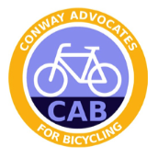
CAB Membership Form

Note: If you would like to pay for your CAB membership with a credit or debit card, visit www.cycleconway.com/store.

Complete the form below and mail it (with your check made to “CAB”) to

CAB, PO Box 833
Conway AR 72033

Membership beginning January 1, _______________ (year). Please note that all memberships expire on December 31, regardless of when in the calendar year you begin your membership.

Full Name: _________________________________________________________________

Home Address (where we will deliver your t-shirt): __________________________________________________________________________

Phone(s) ___________________________________________________________________

Email Address ______________________________________________________________

Membership Type (Check one):
- Individual ($10)
- Family ($15)
- Student/Senior ($5)
- Lifetime ($200)
- Corporate ($100/$250/$500) (circle amount); alternatively, you can email cabcycleconway@gmail.com to discuss which level would be most appropriate for your organization.

